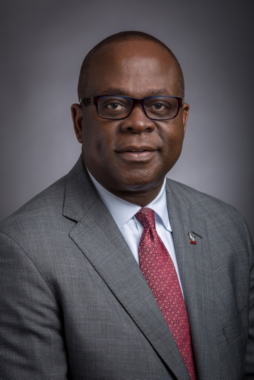
August 2018

Dear NCCU Students,

Welcome to the 2018-2019 academic year. We are delighted that you have chosen North Carolina Central University as the institution where you will further your education over the next four years.

As the 12th chancellor, I am inspired by the vision of NCCU’s founder, Dr. James E. Shepard, who was deeply committed to developing students of character through rigorous academic training and a commitment to public service – principles we still hold dear today.

As part of “The Eagle Promise,” there are four outcomes that we promise each of you that we will fulfill to you upon graduation: on-time degree completion; become socially and globally engaged; demonstrate proven leadership; and graduate market ready.

It is also exciting to consider our institution’s 108-year track record of supporting diversity and inclusion. At NCCU, we have long been accustomed to successfully delivering knowledge and opportunity to all who seek it here.

I urge you to seek out opportunities for civic and community involvement. Explore downtown Durham and the rest of the Triangle region. Volunteer your time to worthy causes – many of which can be found right here at our institution.

We are part of one of the most vibrant regions of the country, a science, technology and entrepreneurship hub that holds potential for each member of our campus community. Make the most of your own assets by engaging with the creators and innovators throughout this region. Synergy often sparks the flame of creativity and leads to new ideas.

Finally, I urge you to stay attuned to the university calendar and take advantage of the many enlightening speakers, forums, public events and opportunities that occur year-round on campus. These programs range from educational seminars and political discussions to courses and lectures designed to bring deeper understanding of our culture.

I am proud, and I hope you are, too, to be associated with this pre-eminent public institution whose commitment to excellence has produced scholars, change agents and innovators since 1910. Here’s to yet another year of fulfilling The Eagle Promise!

In Truth and Service,
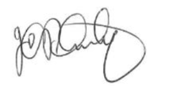

Johnson O. Akinleye, Ph.D.
Chancellor

